What a visitor to my website will see when accessing the site (www.wilburnstrategicsolutions.com):
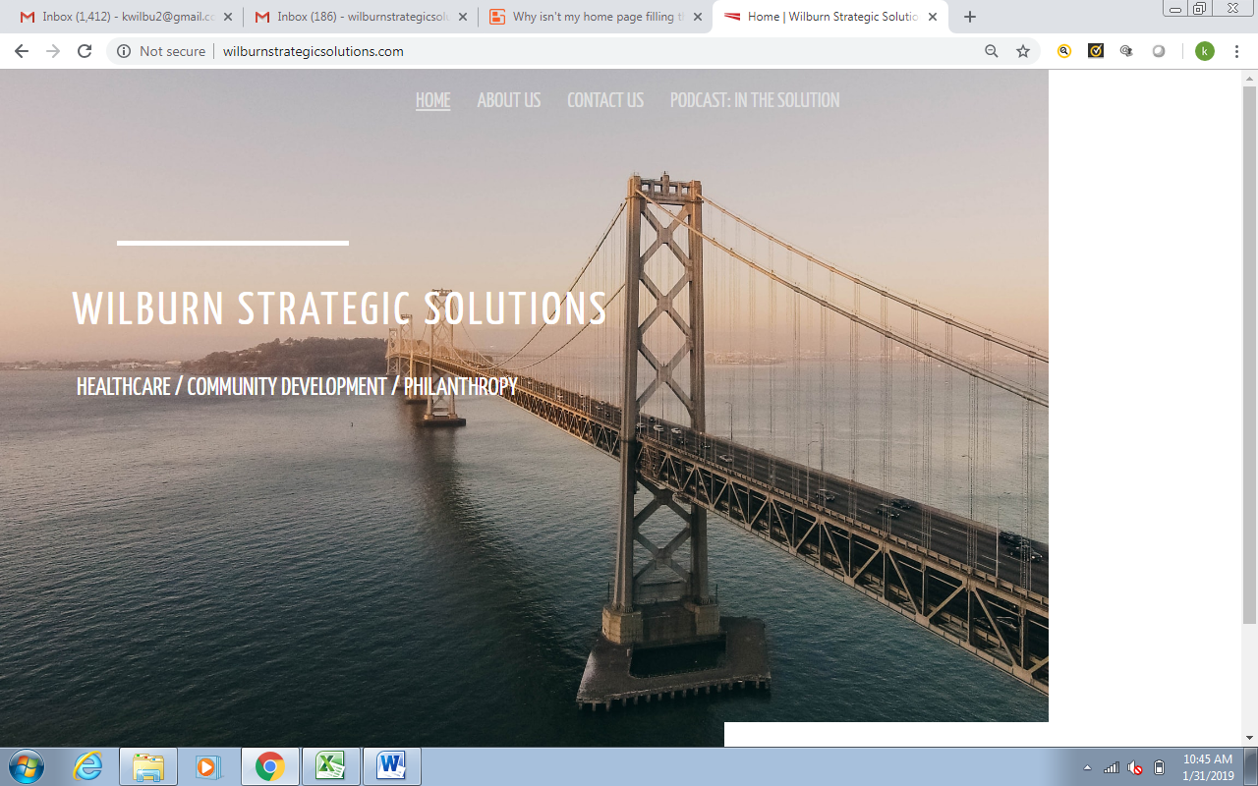

When moving to the “About Us” Page:
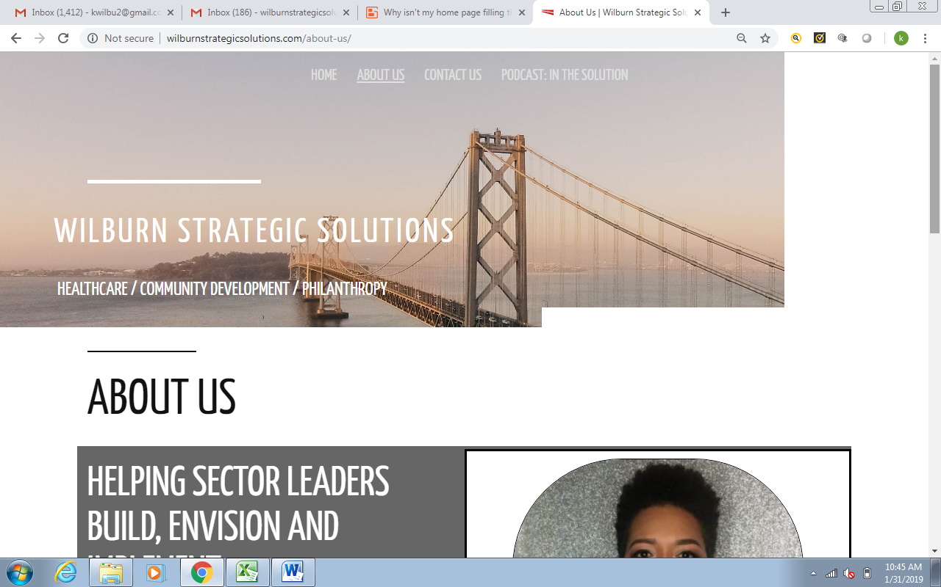

…Contact Us Page:
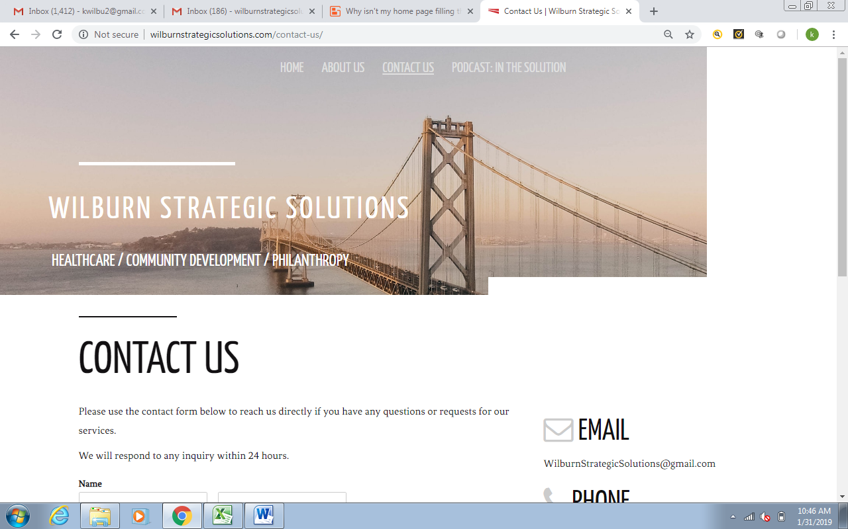

And again with the last/final page, Podcast: In The Solution
